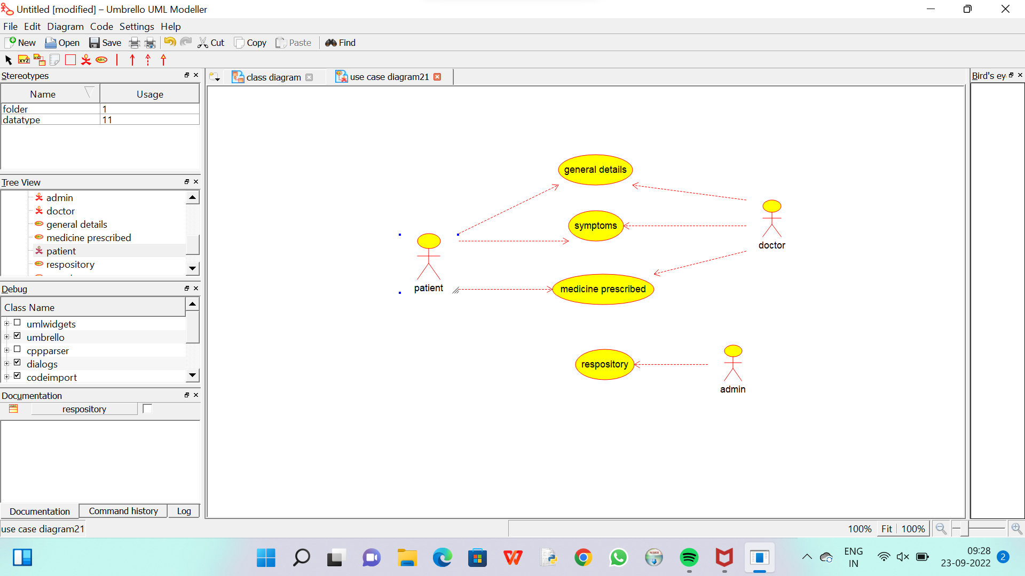

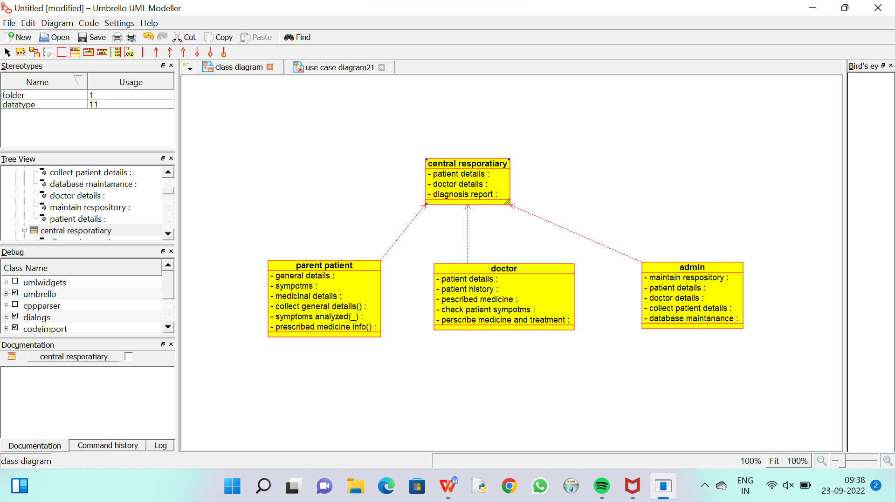

CODE FOR ADMIN :

/**

 * Class admin

 */

public class admin {

  //

  // Fields

  //

  private void maintain_respository;

  private void patient_details;

  private void doctor_details;

  private void collect_patient_details;

  private void database_maintanance;

  //

  // Constructors

  //

  public admin () { };

  //

  // Methods

  //

  //

  // Accessor methods

  //

  /**

   * Set the value of maintain_respository

   * @param newVar the new value of maintain_respository

   */

  private void setMaintain_respository (void newVar) {

    maintain_respository = newVar;

  }

  /**

   * Get the value of maintain_respository

   * @return the value of maintain_respository

   */

  private void getMaintain_respository () {

    return maintain_respository;

  }

  /**

   * Set the value of patient_details

   * @param newVar the new value of patient_details

   */

  private void setPatient_details (void newVar) {

    patient_details = newVar;

  }

  /**

   * Get the value of patient_details

   * @return the value of patient_details

   */

  private void getPatient_details () {

    return patient_details;

  }

  /**

   * Set the value of doctor_details

   * @param newVar the new value of doctor_details

   */

  private void setDoctor_details (void newVar) {

    doctor_details = newVar;

  }

  /**

   * Get the value of doctor_details

   * @return the value of doctor_details

   */

  private void getDoctor_details () {

    return doctor_details;

  }

  /**

   * Set the value of collect_patient_details

   * @param newVar the new value of collect_patient_details

   */

  private void setCollect_patient_details (void newVar) {

    collect_patient_details = newVar;

  }

  /**

   * Get the value of collect_patient_details

   * @return the value of collect_patient_details

   */

  private void getCollect_patient_details () {

    return collect_patient_details;

  }

  /**

   * Set the value of database_maintanance

   * @param newVar the new value of database_maintanance

   */

  private void setDatabase_maintanance (void newVar) {

    database_maintanance = newVar;

  }

  /**

   * Get the value of database_maintanance

   * @return the value of database_maintanance

   */

  private void getDatabase_maintanance () {

    return database_maintanance;

  }

  //

  // Other methods

  //

}

CODE FOR PATIENT :

/**

 * Class parent_patient

 */

public class parent_patient {

  //

  // Fields

  //

  private void general_details;

  private void sympotms;

  private void medicinal_details;

  private void collect_general_details_;

  private void symptoms_analyzed___;

  private void prescribed_medicine_info_;

  //

  // Constructors

  //

  public parent_patient () { };

  //

  // Methods

  //

  //

  // Accessor methods

  //

  /**

   * Set the value of general_details

   * @param newVar the new value of general_details

   */

  private void setGeneral_details (void newVar) {

    general_details = newVar;

  }

  /**

   * Get the value of general_details

   * @return the value of general_details

   */

  private void getGeneral_details () {

    return general_details;

  }

  /**

   * Set the value of sympotms

   * @param newVar the new value of sympotms

   */

  private void setSympotms (void newVar) {

    sympotms = newVar;

  }

  /**

   * Get the value of sympotms

   * @return the value of sympotms

   */

  private void getSympotms () {

    return sympotms;

  }

  /**

   * Set the value of medicinal_details

   * @param newVar the new value of medicinal_details

   */

  private void setMedicinal_details (void newVar) {

    medicinal_details = newVar;

  }

  /**

   * Get the value of medicinal_details

   * @return the value of medicinal_details

   */

  private void getMedicinal_details () {

    return medicinal_details;

  }

  /**

   * Set the value of collect_general_details_

   * @param newVar the new value of collect_general_details_

   */

  private void setCollect_general_details_ (void newVar) {

    collect_general_details_ = newVar;

  }

  /**

   * Get the value of collect_general_details_

   * @return the value of collect_general_details_

   */

  private void getCollect_general_details_ () {

    return collect_general_details_;

  }

  /**

   * Set the value of symptoms_analyzed___

   * @param newVar the new value of symptoms_analyzed___

   */

  private void setSymptoms_analyzed___ (void newVar) {

    symptoms_analyzed___ = newVar;

  }

  /**

   * Get the value of symptoms_analyzed___

   * @return the value of symptoms_analyzed___

   */

  private void getSymptoms_analyzed___ () {

    return symptoms_analyzed___;

  }

  /**

   * Set the value of prescribed_medicine_info_

   * @param newVar the new value of prescribed_medicine_info_

   */

  private void setPrescribed_medicine_info_ (void newVar) {

    prescribed_medicine_info_ = newVar;

  }

  /**

   * Get the value of prescribed_medicine_info_

   * @return the value of prescribed_medicine_info_

   */

  private void getPrescribed_medicine_info_ () {

    return prescribed_medicine_info_;

  }

  //

  // Other methods

  //

}

CODE FOR DOCTOR:

/**

 * Class doctor

 */

public class doctor {

  //

  // Fields

  //

  private void patient_details;

  private void patient_history;

  private void pescribed_medicine;

  private void check_patient_sympotms;

  private void perscribe_medicine_and_treatment;

  //

  // Constructors

  //

  public doctor () { };

  //

  // Methods

  //

  //

  // Accessor methods

  //

  /**

   * Set the value of patient_details

   * @param newVar the new value of patient_details

   */

  private void setPatient_details (void newVar) {

    patient_details = newVar;

  }

  /**

   * Get the value of patient_details

   * @return the value of patient_details

   */

  private void getPatient_details () {

    return patient_details;

  }

  /**

   * Set the value of patient_history

   * @param newVar the new value of patient_history

   */

  private void setPatient_history (void newVar) {

    patient_history = newVar;

  }

  /**

   * Get the value of patient_history

   * @return the value of patient_history

   */

  private void getPatient_history () {

    return patient_history;

  }

  /**

   * Set the value of pescribed_medicine

   * @param newVar the new value of pescribed_medicine

   */

  private void setPescribed_medicine (void newVar) {

    pescribed_medicine = newVar;

  }

  /**

   * Get the value of pescribed_medicine

   * @return the value of pescribed_medicine

   */

  private void getPescribed_medicine () {

    return pescribed_medicine;

  }

  /**

   * Set the value of check_patient_sympotms

   * @param newVar the new value of check_patient_sympotms

   */

  private void setCheck_patient_sympotms (void newVar) {

    check_patient_sympotms = newVar;

  }

  /**

   * Get the value of check_patient_sympotms

   * @return the value of check_patient_sympotms

   */

  private void getCheck_patient_sympotms () {

    return check_patient_sympotms;

  }

  /**

   * Set the value of perscribe_medicine_and_treatment

   * @param newVar the new value of perscribe_medicine_and_treatment

   */

  private void setPerscribe_medicine_and_treatment (void newVar) {

    perscribe_medicine_and_treatment = newVar;

  }

  /**

   * Get the value of perscribe_medicine_and_treatment

   * @return the value of perscribe_medicine_and_treatment

   */

  private void getPerscribe_medicine_and_treatment () {

    return perscribe_medicine_and_treatment;

  }

  //

  // Other methods

  //

}

CODE FOR CENTRAL REPOSITORY :

/**

 * Class central_resporatiary

 */

public class central_resporatiary {

  //

  // Fields

  //

  private void patient_details;

  private void doctor_details;

  private void diagnosis_report;

  //

  // Constructors

  //

  public central_resporatiary () { };

  //

  // Methods

  //

  //

  // Accessor methods

  //

  /**

   * Set the value of patient_details

   * @param newVar the new value of patient_details

   */

  private void setPatient_details (void newVar) {

    patient_details = newVar;

  }

  /**

   * Get the value of patient_details

   * @return the value of patient_details

   */

  private void getPatient_details () {

    return patient_details;

  }

  /**

   * Set the value of doctor_details

   * @param newVar the new value of doctor_details

   */

  private void setDoctor_details (void newVar) {

    doctor_details = newVar;

  }

  /**

   * Get the value of doctor_details

   * @return the value of doctor_details

   */

  private void getDoctor_details () {

    return doctor_details;

  }

  /**

   * Set the value of diagnosis_report

   * @param newVar the new value of diagnosis_report

   */

  private void setDiagnosis_report (void newVar) {

    diagnosis_report = newVar;

  }

  /**

   * Get the value of diagnosis_report

   * @return the value of diagnosis_report

   */

  private void getDiagnosis_report () {

    return diagnosis_report;

  }

  //

  // Other methods

  //

}